# CS 340 README Template

*Use this template to complete your README file. When completing the template, keep the headings as they are so that your document has a clear organization. Remove the italicized prompt text after you have completed each section for a polished final document.*

## Project One: Animal Shelter

*This program is designed to create, read, update, and delete data within the animal shelter database.*

## Motivation

*This program is to evaluate my skill level working with databases and access them through a python program. I utilized the programming language, Python, to access mongoDB. Python compiles quickly as well as being easily understood and written, while having access to tools such as Jupyter Notebook.*

## Getting Started

*This is an example of how you may give instructions on setting up your project locally: “To get a local copy up and running, follow these simple example steps.”*

*Enter the login credentials of the database within the terminal application.*

*Example:*

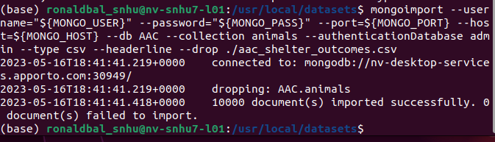 *use the mongosh function to access MongoDB*

*type: use admin, to access the admin features.*

*Create a new user, it’s rights level, and a password for you to access locally.*

## Installation

*For installation you will need:*

*A python compatible IDE*

*MongoDB to access the database and create a user account*

*Within your python IDE you will need to pip install a few things for it to operate correctly.*

*From the terminal:*

*Pymongo: python -m pip install pymongo*

*Jupyter Notebook: pip install notebook. To run the notebook: jupyter notebook*

*You will also need to add these to access the database from your IDE:*

from pprint import pprint //allows pretty printing  
from pymongo import MongoClient //implements the mongo client  
from bson.objectid import ObjectId //query by objectId

## Usage

*Use this space to show useful examples of how your project works and how it can be used. Be sure to include examples of your code, tests, and screenshots.*

### Code Example

*Show what the library does as concisely as possible. Developers should be able to figure out how your project solves their problem by looking at the code example. Make sure that your code is short and concise.*

*This project allows a user to create, read, update, and delete information held within the animal shelter database. In testing this, generate a code that creates a new and unique ID number that can be associated to the animal through the use of joining at random a series of ascii characters and numbers. Print the number to show that it was created properly then, create the appropriate information necessary to add the animal to the shelters database.*

*Method to create and insert a new document within the database*

*The argument is a key and value pair within the data type that the database will accept to call the API*

*True will be returned when the insertion is accepted and returned false if it was inserted incorrectly.*

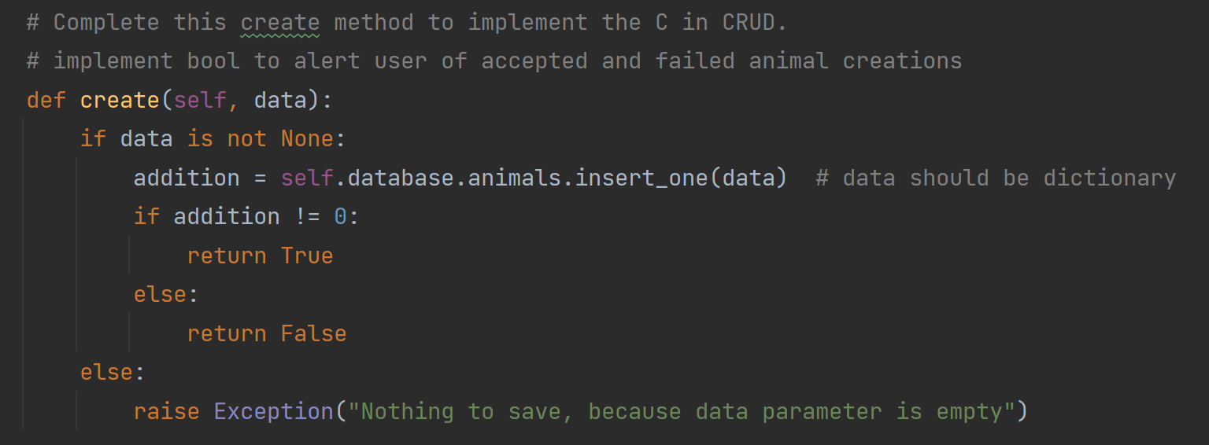

*Method to read document data within the database and collection*

*Key and value pairs are used in conjunction with the mongoDB and API call*

*The data will be returned upon a successful call to read data*

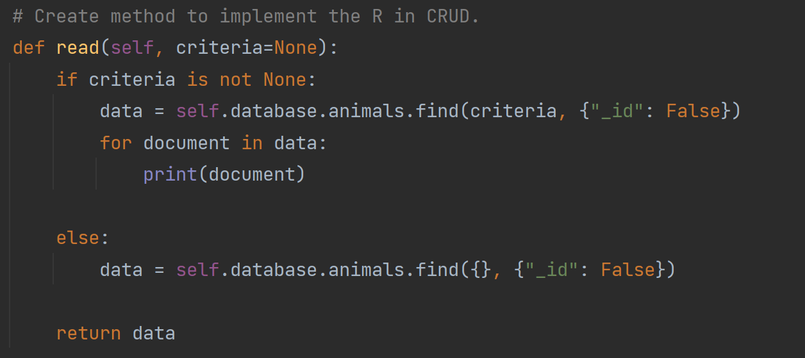

*Method that updates data within a database and collection*

*Key and value pairs used to look up existing data within a database and collection and return updates made to the query*

*The result is returned upon a successful update, otherwise a message is displayed when a document isn’t found. Unsuccessful updates return an exception*

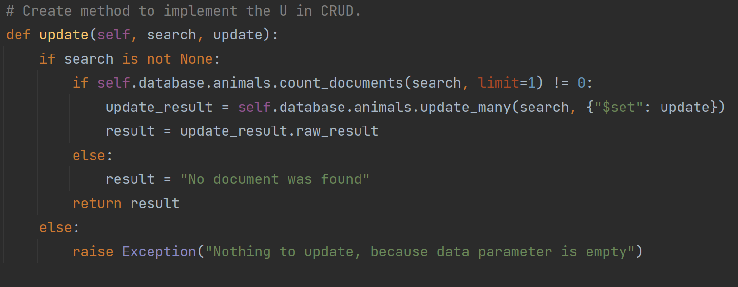

*Method that deletes existing documents within the database and collection*

*Key and value pairs are used to query for existing information*

*Result returned upon successful deletion, otherwise an exception is thrown*

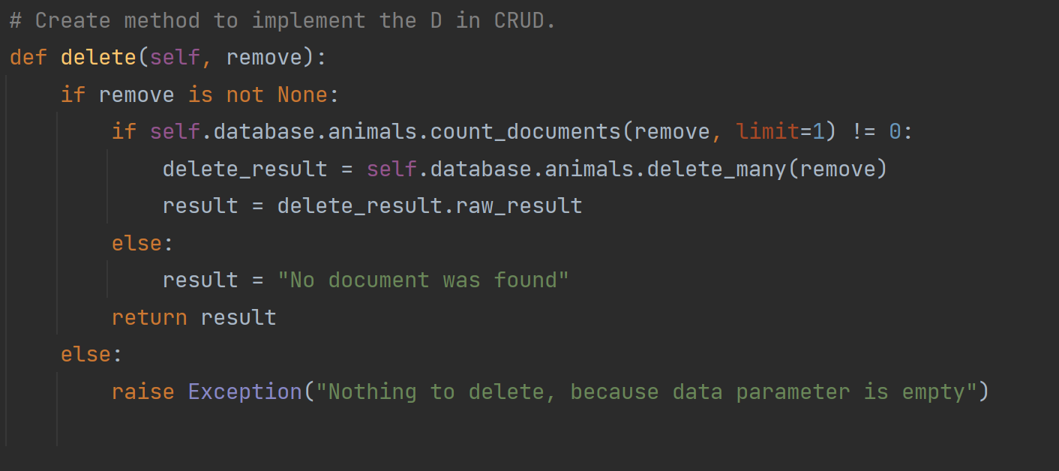

### Tests

*This test shows the successful creating of a new animal within the database which is verified by the animals new ID number being printed to the output.*

### Screenshots

Successful importation of the animal database and authentication

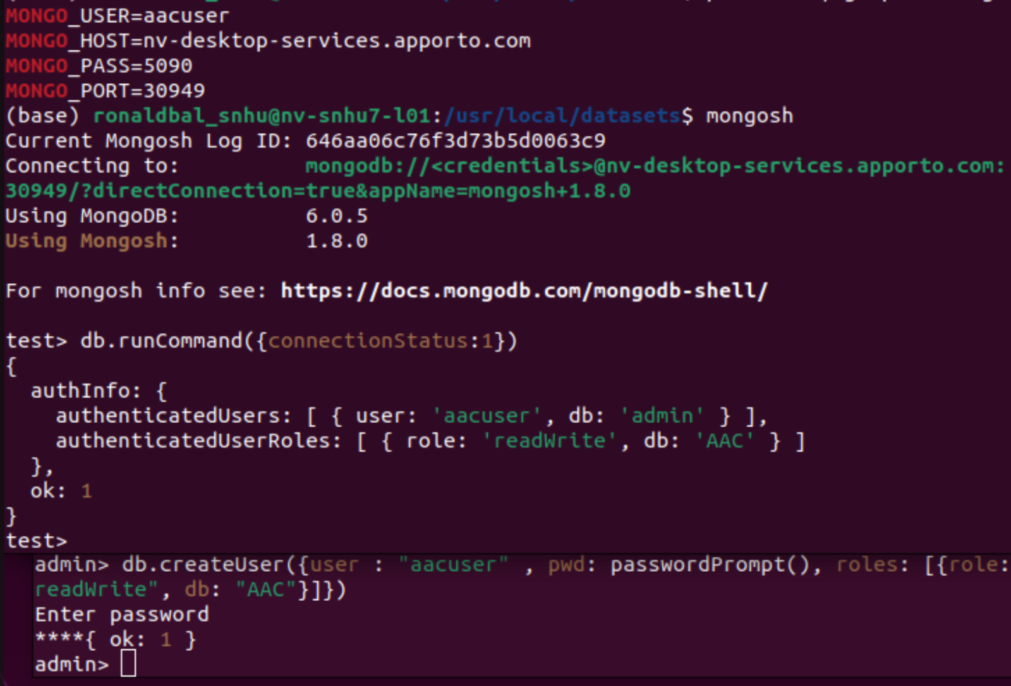

New document entry

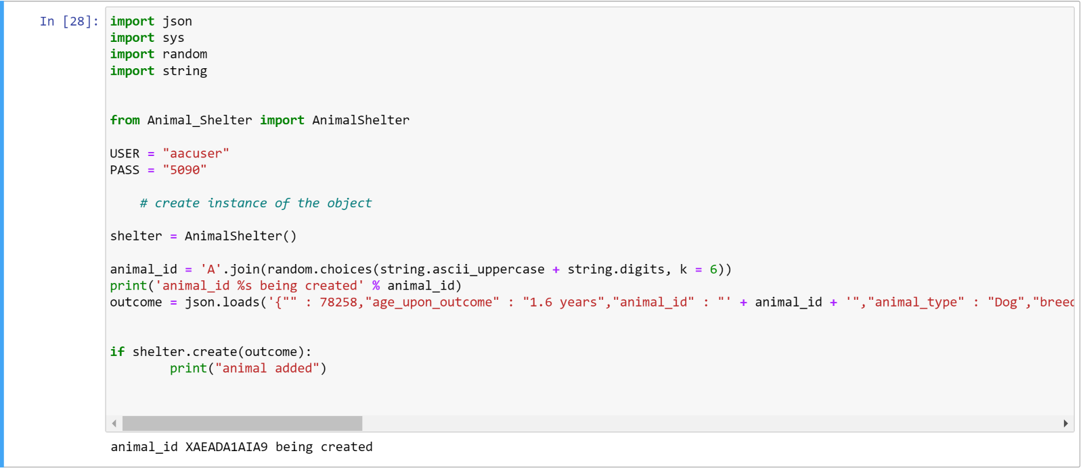

*Invalid document entry*

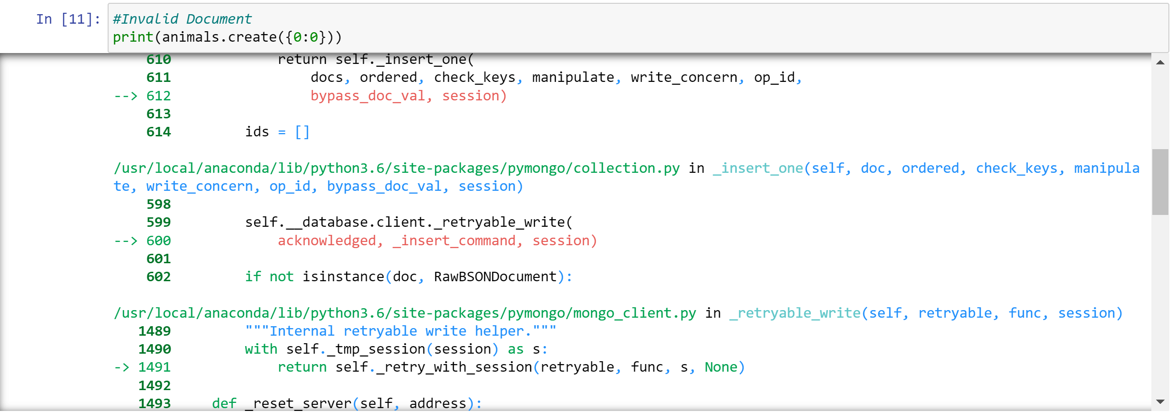

## Roadmap/Features (Optional)

*Query created animal within database*

**

*Invalid query search*

**

*Document update*

**

*Invalid document update*

**

*Valid document delete*

**

*Invalid document delete*

**

*My code was unable to access the database so, I wasn’t able to show the working program:*

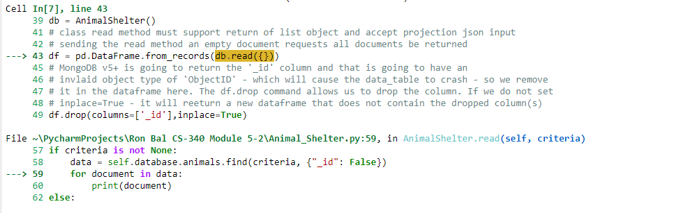

*Provide an open issues list of proposed features (and known issues). If you have ideas for releases in the future, it is a good idea to list them in the README. What makes your project stand out?  
  
Note: This section is optional for the purposes of this assignment. If you choose not to fill out this section, remove it from your final README file.*

## Contact

Your name: Ron Bal